**RIWORK**

**(REIMAGINING WORKPLACES)**

**UIT2511 – SOFTWARE DEVELOPMENT PROJECT – II**

**A PROJECT REPORT**

***Submitted by***

**Adharsh Gurudev – 3122 21 5002 004**

**Aditi Rajesh – 3122 21 5002 005**

**Ahamed Jumail M – 3122 21 5002 006**

**SSN COLLEGE OF ENGINEERING,**

**KALAVAKKAM**

**OCTOBER 2023**

**Sri Sivasubramaniya Nadar College of Engineering**

**(An Autonomous Institution, Affiliated to Anna University)**

**BONAFIDE CERTIFICATE**

Certified that this project titled “Riwork” is the bonafide work of “Adharsh Gurudev (3122215002004), Aditi Rajesh (3122215002005), Ahamed Jumail M (3122215002006)”, and is submitted for project viva-voce examination held on <Date of viva-voce examination>.

**Signature of examiner(s)**

**ABSTRACT**

The hybrid workplace is a concept on the lips of every industry trend in the world today. With digitalization becoming more normalized across every sphere in the global village. Every workplace needs to maximize and transcend obstacles and innovations to ease into the hybrid workplace. The COVID-19 pandemic brought a wave for an increased need for a hybrid workplace. The pandemic has taught the work a lesson of preparation and planning. Beyond that is also the lesson of flexibility and adaptability in the workplace.

The future of work would likely be the hybrid workplace model. In prioritizing the future of work, there is the need to embrace the hybrid workplace model. Our project is based on simplifying the process of the hybrid workplace allocation and workspace management. This project reimagines the workspaces and allots the workplaces to the employees a team. This product is named a “RIWORK” which means Re-Imagining Workspaces. Riwork is specified as reimagination as, Artificial Intelligence strategies are used to find the solutions for the prevailing problems. The contribution of AI is in the main feature of Riwork.

The three main features of this product: First, all the employees of an organization work as teams particularly in IT industries. We allot office days – employees should go to office for work rather than working from home. We allot the office days for all the teams of the company in such a way that all the employees have equal number of working days. This is done using a strategy of Random Selection.

Second, is to allot offices to the teams keeping in mind the efficient use of the workspaces of the offices. After random selection of the teams for each working day, the total number of workers allotted with office day on the particular day is calculated. To efficiently use the workspaces of the offices, we ensure that there are no workspaces exploited for the welfare of the office. This is done using the AI strategy called as Genetic Algorithm. Third, all the employees of a particular team should be allotted with same office. Riwork ensures that, a team is allotted with an office which is nearer to the residence of all the employees of a team. This is done using the strategy of Heuristic Search integrated with Haversines Formula for calculating the distances between the offices and the employees.

Riwork is tested with dynamic inputs to ensure if the algorithm behind that works properly when there is a more than one choice of office to be allotted and also to ensure if all the teams have equal number of office days in a week and also to ensure if the database connectivity is perfect regarding with the login of employees and fetching of the distances from the database using mongo DB.

**INTRODUCTION**

**MOTIVATION:**

The Covid-19 pandemic quickly altered the traditional office work as we have got accustomed to for the past decade and once crowded office buildings were diminished to rows of vacant desks. After that primary swirl, many started questioning if the office life as we know is the optimal arrangement or if organizations should consider implementing a new way of work where employees have the option to both work at the office as well as working remotely. Preceding the pandemic, the established percipience had been that offices were paramount to winning the war for talent, culture and productivity. Organizations competed intensely for superior real estate in urban centers around the world, and many focused-on solutions that were seen to stimulate collaboration, such as open-office designs, co-working, densification and hoteling.

**PROBLEM STATEMENT:**

The working days for the employees are predominantly five days in a week. Going to office all the day brings out lots of issues for both employees and the companies. Accommodating all the employees in all working days in the office is tedious and not needed. To simply this, there is a need of an application to allot office days to the employees and allot workplace for the employees by efficiently using the workspaces of the office. And also, the assign the office nearer to all the employees of a particular team. The above requirements should be fulfilled using AI strategies.

**OBJECTIVE:**

The core objective of the Riwork project is to revolutionize workplace dynamics by effectively implementing the hybrid workplace model. With a focus on optimizing the balance between in-office and remote work, Riwork employs advanced Artificial Intelligence (AI) strategies. The project aims to ensure an equitable distribution of office days among all teams and employees, employing the Random Selection algorithm to guarantee each employee an equal number of office days per week. Additionally, Riwork utilizes the power of Genetic Algorithm to efficiently allocate offices, minimizing resource wastage and enhancing workspace utilization. The system further incorporates Heuristic Search integrated with Haversines Formula to assign offices based on geographic proximity, fostering team collaboration by reducing commuting times. Rigorous dynamic testing is conducted to validate the robustness of the system, emphasizing adaptability to various scenarios and multiple office choices. Furthermore, the project aligns with future work trends, striving to create a model that is not only responsive to current challenges but also poised to embrace emerging work dynamics and technological advancements, ultimately promoting organizational efficiency, fairness, and employee well-being.

**DELIVERABLES:**

* A fully functional software application named RIWORK, providing an intuitive user interface for employees and administrators.
* implementation of the Random Selection algorithm for equitable distribution of office days among employees and teams, ensuring fairness and balance.
* optimizes workspace allocation, focusing on maximizing efficiency and minimizing resource wastage within office spaces.
* to assign offices based on geographic proximity, reducing commuting times for teams.
* Facilitate through MongoDB integration, is rigorously tested to ensure seamless data retrieval for workspace allocation. User documentation and training materials are crafted to facilitate a smooth onboarding process for all users.

**REQUIREMENT ENGINEERING**

**CLIENT DETAILS:**

**Name :** Dr. Srinivasan

**Profession :** Professor, SSN College of Engineering.

**Email ID :** [srinivasanr@ssn.edu.in](mailto:srinivasanr@ssn.edu.in)

**FUNCTIONAL MODULES:**

* User Authentication Module
* Random Team Selection Algorithm Module
* Genetic Algorithm Module
* Heuristic Search Module
* Database Connectivity Module
* User Interface Module

**IMPLEMENTATION AND RISK MANAGEMENT**

**INDIVIDUAL CONTRIBUTION:**

**Name:** Adharsh Gurudev

**Register Number:** 3122 21 5002 004

**Role in the Project:** Developer

**A. Implementation**

|  |  |  |  |  |
| --- | --- | --- | --- | --- |
| **Sprint** | **Epic** | **User Story** | **Requirement** | **Remarks on implementation** |
| 1 | Implementing genetic algorithm on the basis of workspace capacity and team split. | genetic algorithm This algorithm should consider the current workspace capacity and team composition to intelligently optimize task allocation and team assignment. This way, we can enhance overall productivity, streamline workflow, and ensure that each team member is working in an environment that maximizes their efficiency. | Implementing Genetic Algorithm for Resource Optimization | Successfully implemented genetic algorithm using crossover and mutation |
| 1 | Implementig distance as a decision factor and incorporating it into the fitness function of the genetic algorithm | Implementing a distance matrixas a decision factor helps enhance the genetic algorithm. This will enable the algorithm to consider geographical proximity when assigning tasks to team members, promoting efficient communication and collaboration. | Enhancing Genetic Algorithm with Distance Factor | Implementation done successfully using Haversine’s formula. |

**B. Risk Management**

|  |  |  |  |  |
| --- | --- | --- | --- | --- |
| **Risk** | **Risk Description** | **Probability** | **Impact** | **Mitigation Plan** |
| Inadequate data availability | The genetic algorithm relies on accurate and comprehensive data regarding workspace capacity and team composition. Incomplete or inaccurate data could lead to suboptimal task assignments. | Moderate | High | implement data validation checks and work closely with relevant teams to ensure accurate and complete data is available. Regularly update the data sources to maintain accuracy. |
| Scalability Issues | The genetic algorithm may encounter scalability issues as the size of the teams and the complexity of workspace configurations increase, resulting in performance degradation. | Low to Moderate | High | Design the algorithm with scalability in mind, conduct performance testing with simulated large datasets, and optimize the code for efficiency. Implement monitoring to identify and address scalability issues early. |
|  |  |  |  |  |

**Name:** Aditi Rajesh

**Register Number:** 3122 21 5002 005

**Role in the Project:** Lead / Developer

**A. Implementation**

|  |  |  |  |  |
| --- | --- | --- | --- | --- |
| **Sprint** | **Epic** | **User Story** | **Requirement** | **Remarks on implementation** |
| 2 | Using MongoDB to store Company records as well as employee records | MongoDB must be used to store and organize comprehensive data sets efficiently. This implementation will enable our system to seamlessly manage both company and employee records, facilitating easier retrieval, updates, and scalability. | MongoDB Integration for Company and Employee Records | Successfully implemented MongoDB as database for Company and Employee records, and created collections and documents for the same |
| 2 | Integration of database with the backend and obtaining tabular information on work schedules for each employee | This integration should facilitate the retrieval of tabular information on work schedules for each employee. By having a centralized and efficient method to access and analyze work schedules, I aim to enhance workforce management and improve overall operational efficiency. | Integration of Database with Backend for Work Schedule Information | Successfully integrated database with the backend using PyMongo and tabulated the work schedule for each employee using pandas |

**B. Risk Management**

|  |  |  |  |  |
| --- | --- | --- | --- | --- |
| **Risk** | **Risk Description** | **Probability** | **Impact** | **Mitigation Plan** |
| Database Connectivity Issues | Challenges may arise in establishing and maintaining stable connections between the backend system and the database, leading to disruptions in retrieving work schedule information. | Moderate | High | Implement connection pooling, conduct thorough testing of database interactions, and monitor connection stability. Have backup connection strategies in case of failures. |
| Data Inconsistency | Inconsistencies in work schedule data between the backend and the database could occur, leading to incorrect or outdated information being presented to users. | Moderate | Moderate to High | Implement data validation checks during data insertion and updates. Set up data synchronization processes to ensure consistency between the backend and the database. |
|  |  |  |  |  |

**Name:** Ahamed Jumail M

**Register Number:** 3122 21 5002 006

**Role in the Project:** Developer

**A. Implementation**

|  |  |  |  |  |
| --- | --- | --- | --- | --- |
| **Sprint** | **Epic** | **User Story** | **Requirement** | **Remarks on implementation** |
| 3 | Creating Login Authentication page using streamlit | This page should provide a secure and user-friendly interface for entering and validating login credentials. By having a reliable authentication mechanism, we aim to enhance the overall security of the application and ensure that only authorized users can access sensitive information. | Streamlit Login Authentication Page | Successfully implemented a login authentication service using the streamlit_authenticator module |
| 3 | Creating a Main Page that explains the functioning of the website. | This page should serve as an informative guide, introducing users to key functionalities, benefits, and navigation pathways. By having a well-structured Main Page, we aim to enhance user understanding and engagement with the website. | Creating Main Page for Website Functionality Explanation | Successfully implemented the Main Page using streamlit and utilised surveys to help clarify the importance of this application |

**B. Risk Management**

|  |  |  |  |  |
| --- | --- | --- | --- | --- |
| **Risk** | **Risk Description** | **Probability** | **Impact** | **Mitigation Plan** |
| Streamlit Framework Limitations | Streamlit may have limitations in terms of customization and flexibility for creating a robust and secure login authentication page. | Moderate | Moderate to High | Conduct a thorough analysis of Streamlit's capabilities and limitations. Explore workarounds or consider alternative frameworks if specific requirements cannot be met. |
| Compatibility Issues with Authentication Services | Integration with existing authentication services or databases may face compatibility issues with Streamlit. | Low to Moderate | Moderate | Ensure thorough testing and compatibility checks with authentication services. Implement adapters or connectors if needed to bridge any compatibility gaps. |
|  |  |  |  |  |

**C. Test Log Report**

|  |  |  |  |  |
| --- | --- | --- | --- | --- |
| **TC id** | **Test case description/ condition** | **Test case input** | **Expected Output** | **Result (PASS/ FAIL)** |
| 1 | Testing genetic algorithm’s accuracy for 10 teams | 156 employee records along with workspace records | Efficient allocation such that all members of the team are in the same workspace | PASS |
| 2 | Incorporating MongoDB with Python using PyMongo to add, delete and manipulate data | Employee details such as empid,empname etc, and office details | Successful addition of consistent data into the backend | PASS |
| 3 | Testing User Authentication and ensuring data is consistent with the database | Employee username, password | Successfully logging in when the credentials are correct, and denying entry when wrong. | PASS |

**PROJECT MANAGEMENT**

**JIRA SCREENSHOTS**

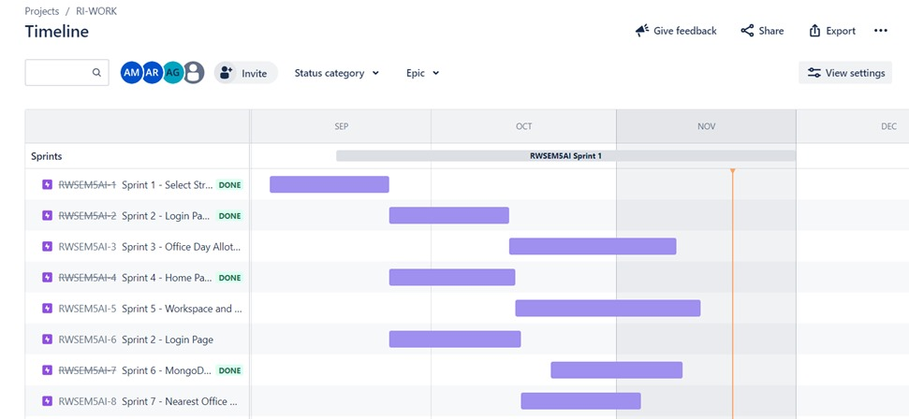

**PROJECT OUTCOMES**

**CODE SNIPPETS:**

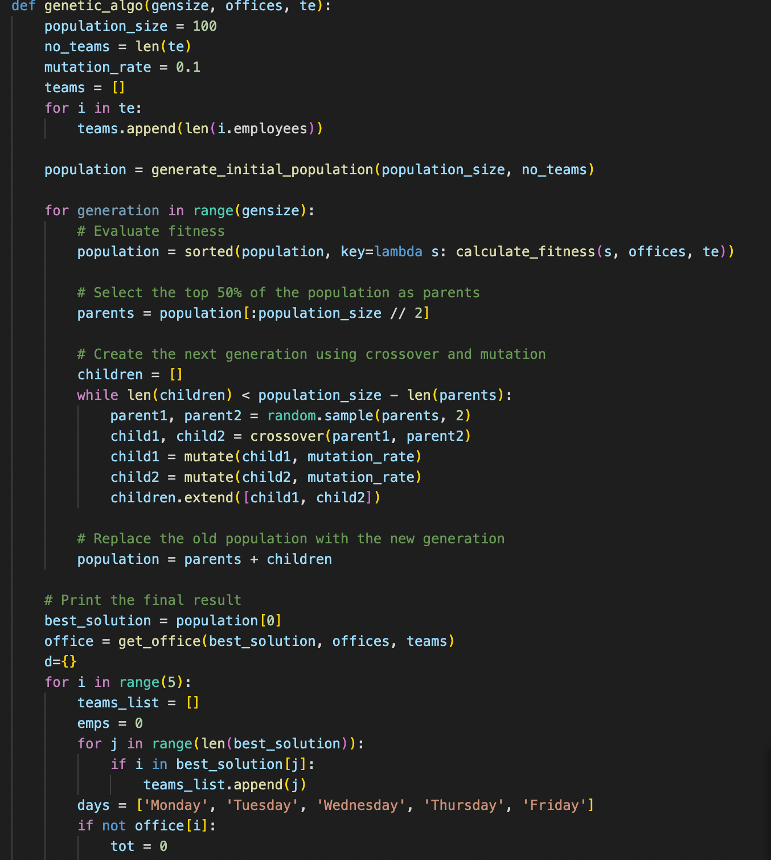

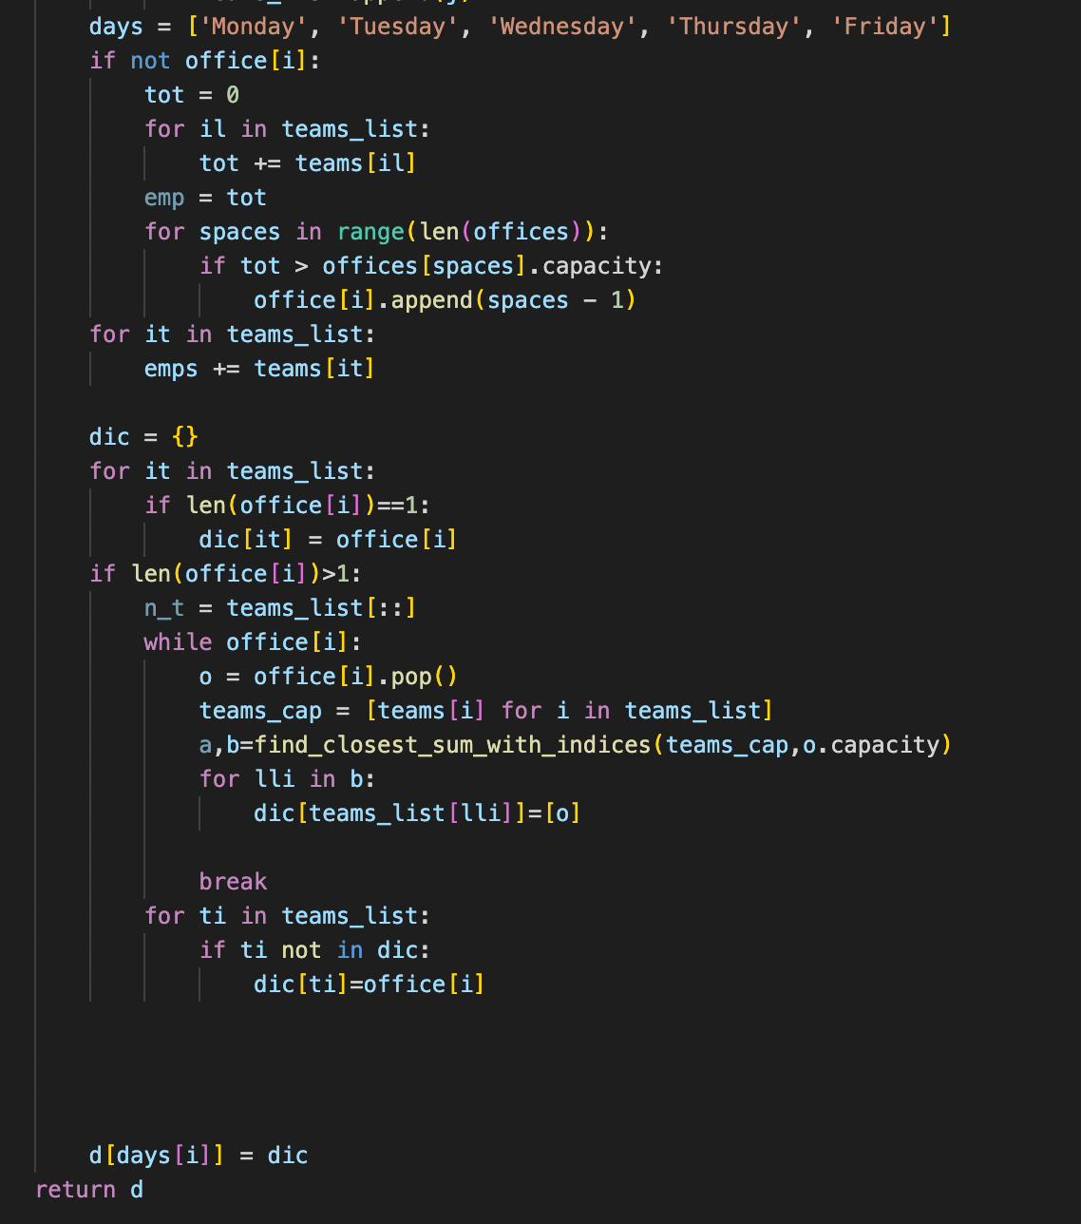

**DATABASE CONNECTIVITY:**

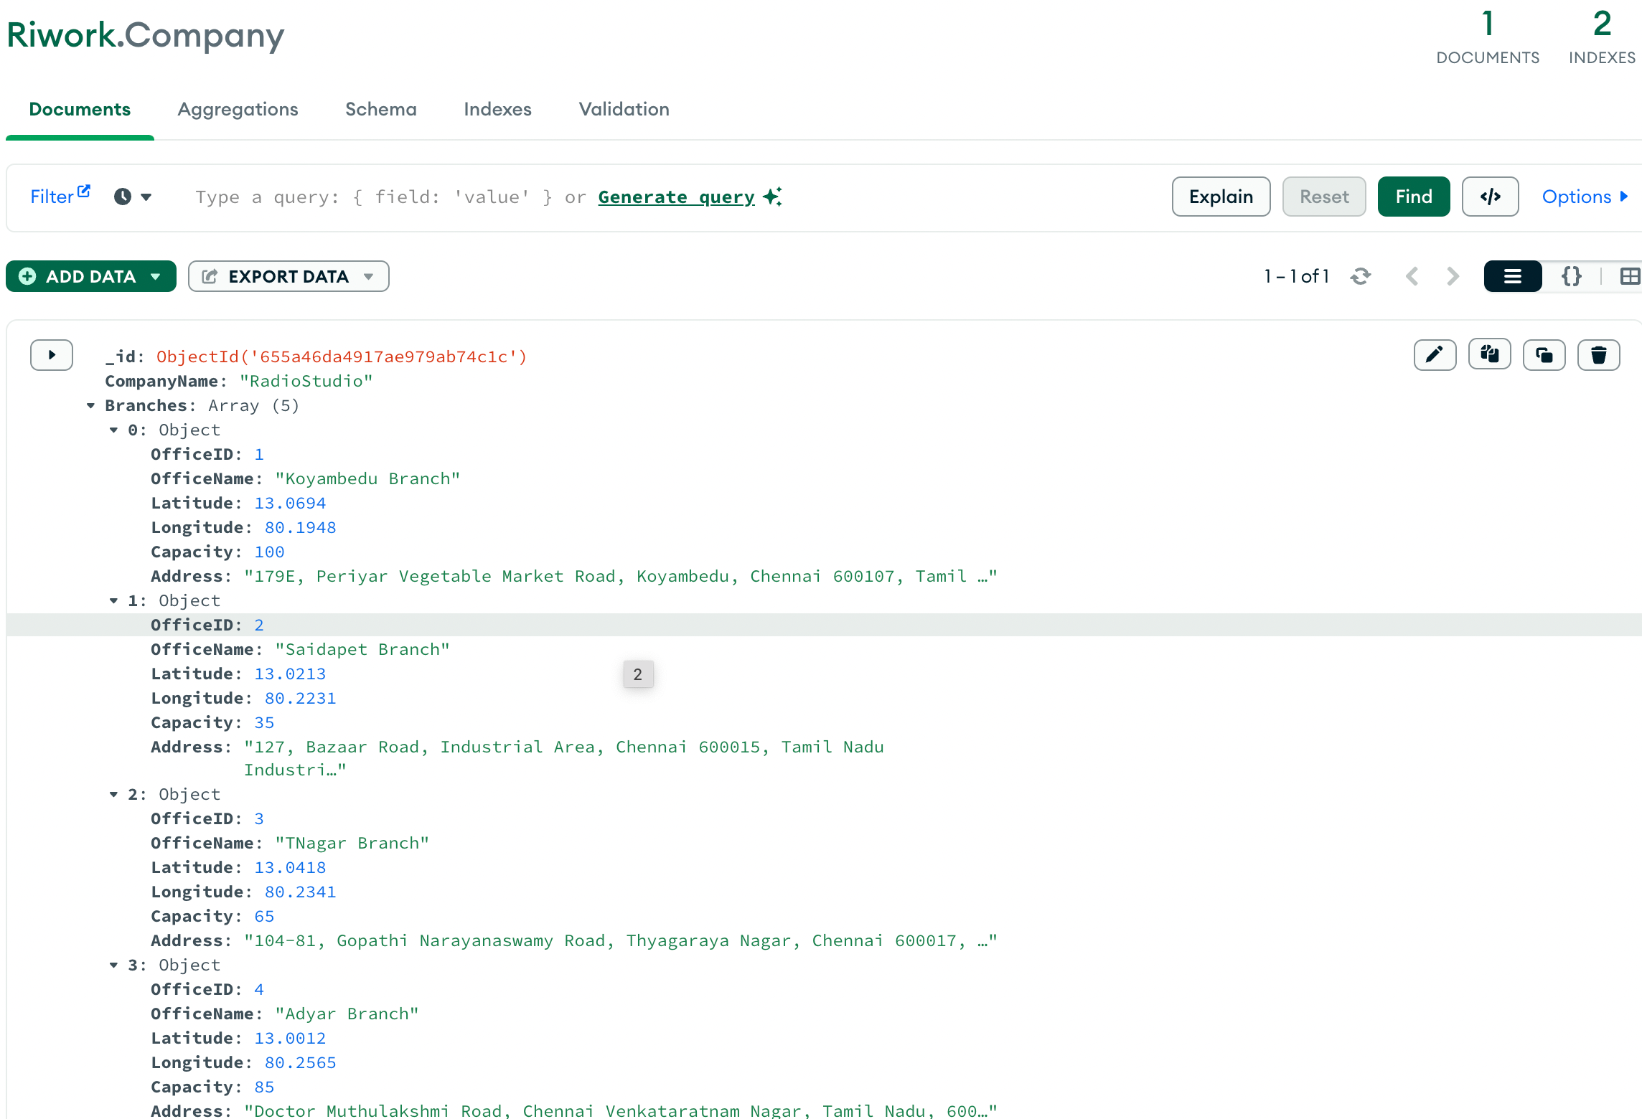

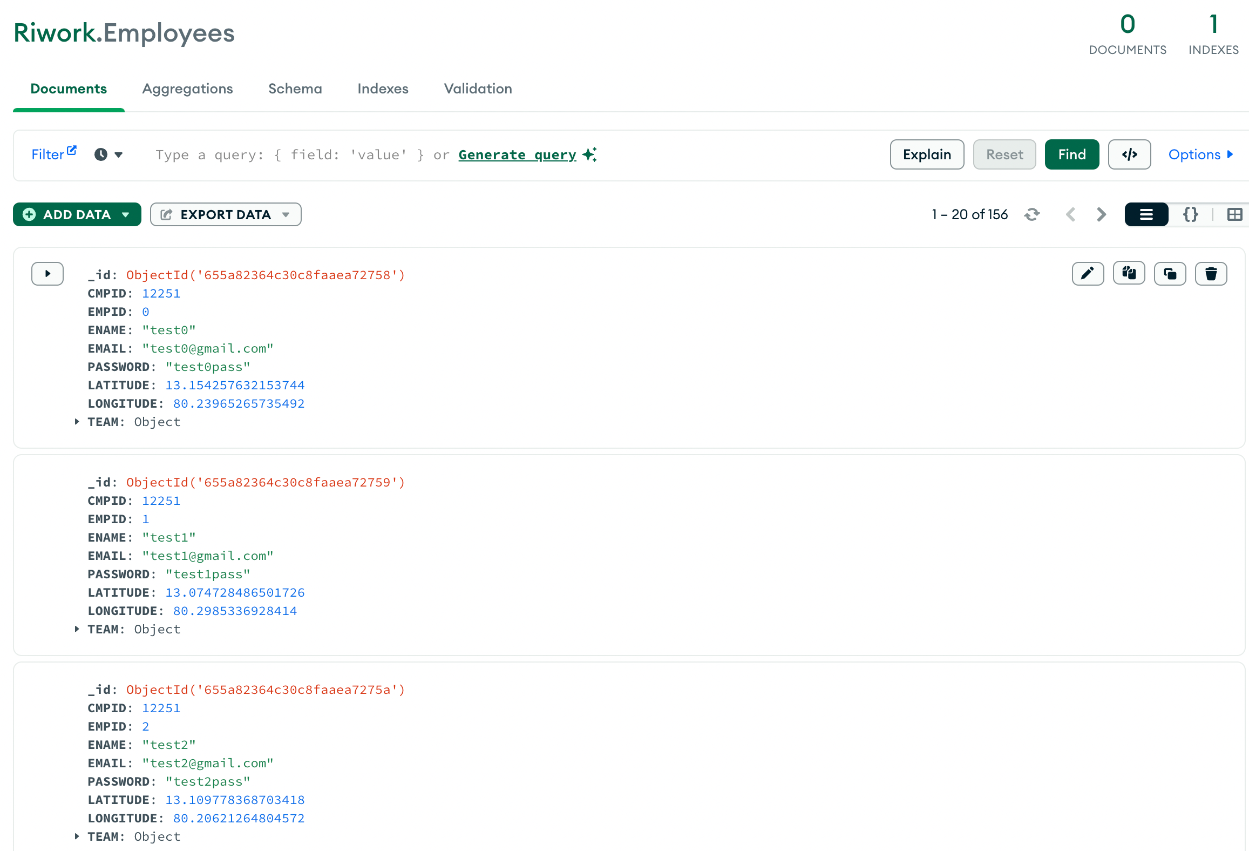

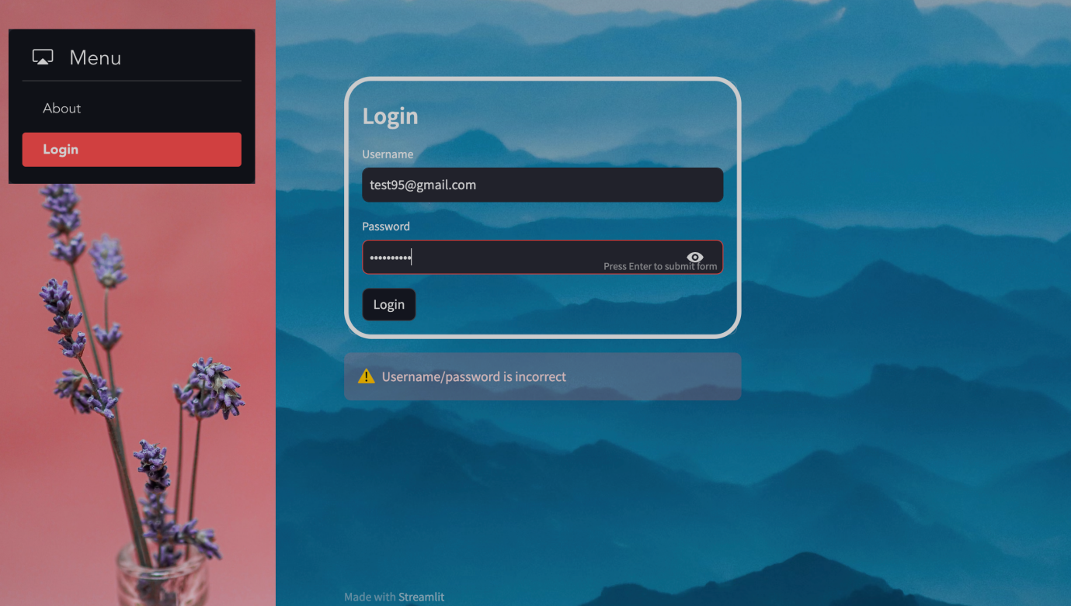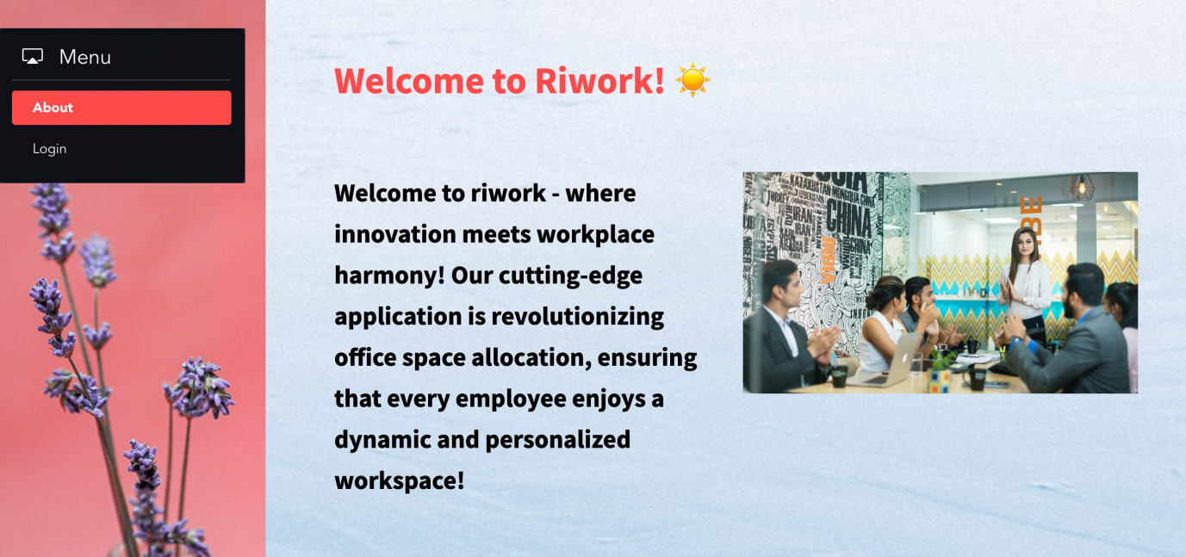**FRONTEND SCREENSHOTS:**

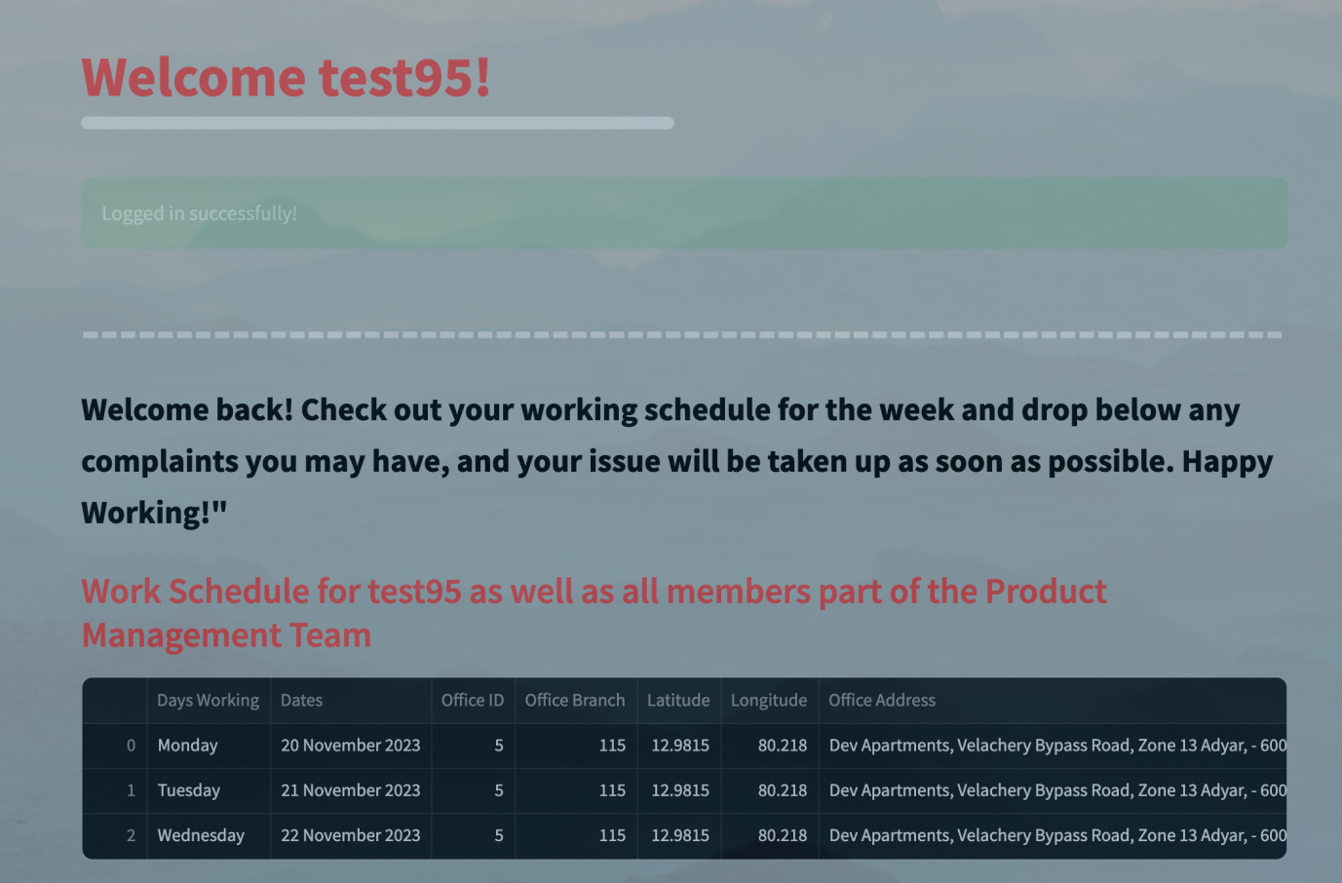

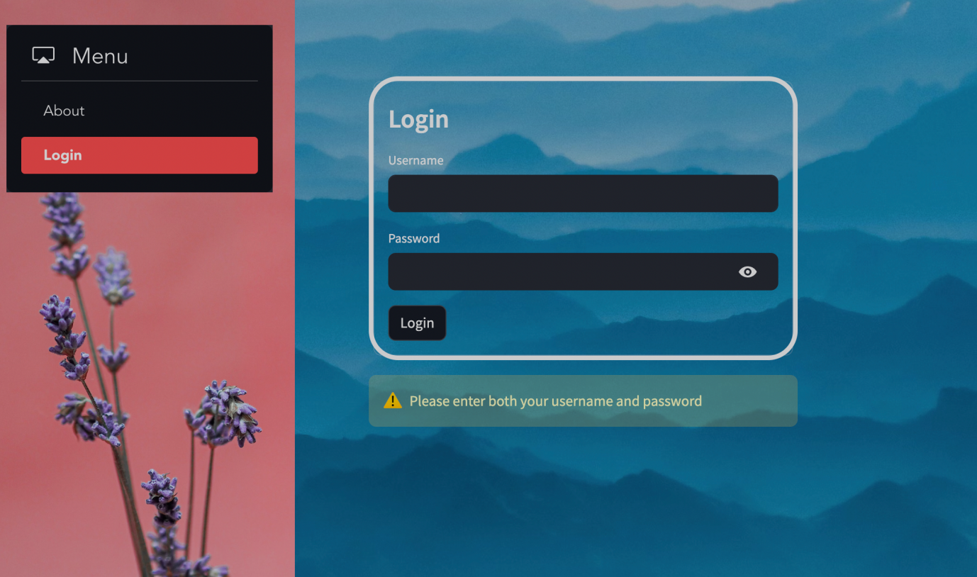

**EVALUATION**

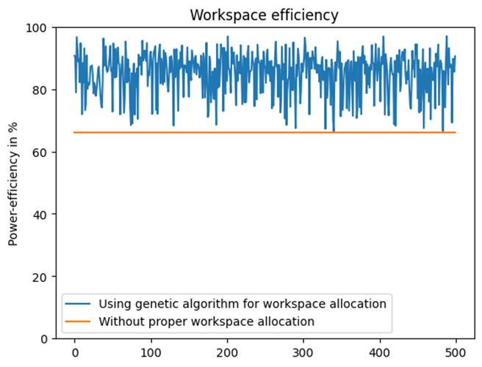

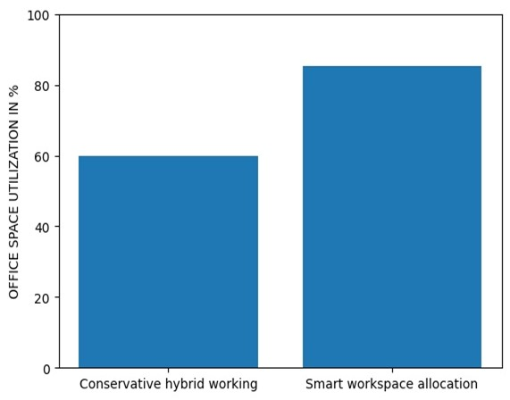

The major loss is the loss in power and resources if the workspaces are not allocated efficiently. A study by Harvard business review found that only two thirds of the workspace is used while the whole workspace is powered.

Using smart allocation techniques, we can significantly improve the power efficiency of such workspaces.

Here is a graph representing efficiency generated by using genetic algorithm and distance-based allocation for 500 different iterative test cases.

**CONCLUSION**

The main challenges that were faced during the development of Riwork is, fetching of location of the employees’ residence and then the genetic algorithm particularly for this problem gives an efficient solution only when it undergoes more crossovers between generations. There was more problem in connecting MongoDB with the backend code.

Mostly, every step that were made during the development went right other than bringing out efficiency. At first, Heuristic Search Strategy was used to bring out all the three features of Riwork. But it didn’t work well on the basis of efficiency for most of the test cases. Then there was a scope of Genetic Algorithm which paved way to fulfill the requirements efficiently and successfully.

To release this product in public domain, there should be a better knowledge in debugging the errors that occur in database connectivity and moreover it is important to learn more about the API for the login authentication.

In conclusion, the RIWORK project endeavors to redefine the landscape of workplace management by embracing the hybrid model and leveraging Artificial Intelligence strategies. In essence, RIWORK represents a significant step toward an efficient, fair, and employee-centric hybrid workplace. The successful development and implementation of the project underscore its potential to revolutionize how organizations manage their workforce in the evolving landscape of work. As we look ahead, RIWORK stands as a testament to the possibilities that arise when technology and innovation converge to address the pressing needs of the modern workplace.

**FUTURE DIRECTIONS**

Integrate machine learning techniques to analyze and understand individual employee preferences, enabling the system to tailor office day and workspace assignments based on historical data and personalized patterns.

Extend the geographic scope of the system to accommodate organizations with multiple office locations, considering factors such as regional preferences, commuting patterns, and varying workplace regulations.

Implement a robust feedback mechanism within the system, allowing employees to provide insights on their hybrid work experiences, preferences, and suggestions for improvement, fostering a collaborative and responsive workplace culture.

Address the unique challenges and considerations of organizations with a global workforce, taking into account cultural nuances, time zone differences, and diverse legal and regulatory frameworks.

**REFERENCES**

[1] Bauer, W., Schlund, S., & Vocke, C. (2018). Working life within a hybrid world – How digital transformation and agile structures affect human functions and increase quality of work and business performance. Advances in Intelligent Systems and Computing, 594, 3–10. doi:10.1007/978-3-319-60372-8_1

[2] <https://youtu.be/4SpdnG3xmXE?si=QEplYj0cV-T9HB2d>

[3] <https://ieeexplore.ieee.org/abstract/document/7257301>

[4] <https://chat.openai.com/share/c2b0c5e1-cc95-459f-bfcf-16d9a9d86fba>

[5] Stuart Russell and Peter Norvig, “Artificial Intelligence – A Modern Approach”, Fourth Edition, Pearson Education, 2021.